Create a Stream Analytic Job

1. In the [Azure portal](http://portal.azure.com/), click Create a resource then select **Internet of things** and then **Stream Analytics Job**

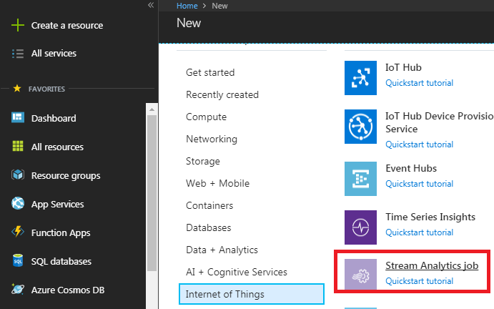

1. Enter a unique job name and verify the subscription is the correct one for your job. Then either create a new resource group or select an existing one on your subscription
2. Then select a location for your job. For speed of processing and reduction of cost in data transfer selecting the same location as the resource group and intended storage account is recommended.

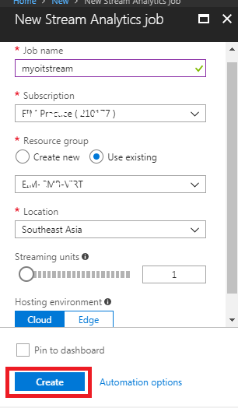

1. Check the box to place your job on your dashboard and then click **CREATE**.
2. You should see a 'Deployment started...' displayed in the top right of your browser window. Soon it will change to a completed window as shown below.
3. After your job is created it's time to open it and specify Input / output and build a query. You can easily access your job by clicking the tile for it.

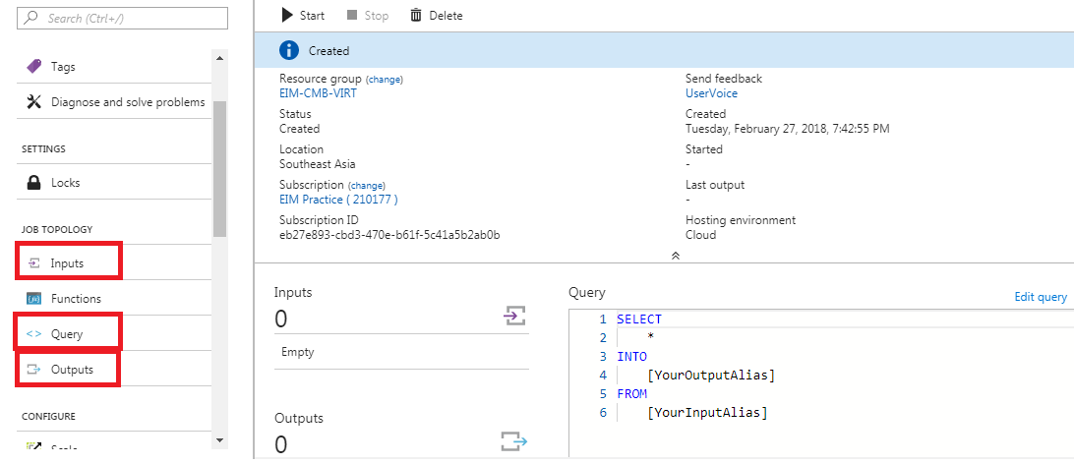

## Create an Azure Stream Analytics Input

1. Click inputs under job topology
2. Add streaming inputs and select IoT Hub

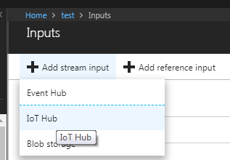

1. Specify required fields as given below
2. And Click create.

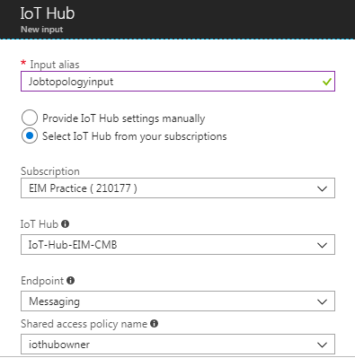

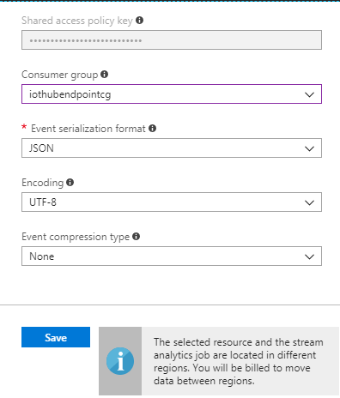

## Create an Azure Stream Analytics Output

1. Click output under job topology
2. Add Power BI

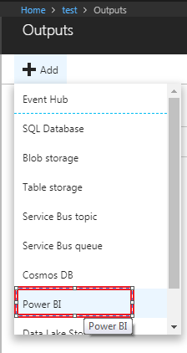

1. Specify required fields as given below

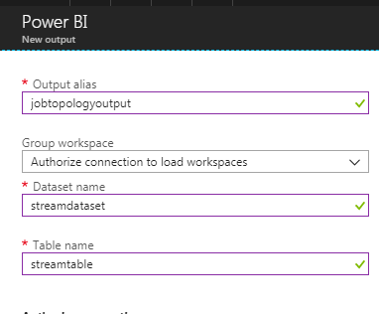

1. Click save

## Create an Azure Stream Analytics Query

1. Click on edit query:

SELECT

*,

SQRT(jobtopologyinput.x*jobtopologyinput.x +jobtopologyinput.y*jobtopologyinput.y+jobtopologyinput.z*jobtopologyinput.z) As Accelerator,

DATEADD(minute,30,DATEADD(hour,5,jobtopologyinput.EventEnququedUtcTime)) as system_time

INTO

jobtopologyoutput

FROM

Jobtopologyinput

1. Save and Test

